Welcome to our 'What's On' email
Friday 4th October 2024

 | Place | Activity
Sunday 6th  9am | Rodborough | Morning Worship Service– contact John Atkinson jka1649@gmail.com or Ian Sullivan daveofjudea@hotmail.com for details
Sunday 6th  11am | Woodchester | Morning Worship Service with creche and activities for older children – contact Nick Ardagh-Walter nickandamanda1558@gmail.com or Liz Cole elizcolehome@gmail.com for details
Sunday 6th  11am | Brimscombe | Harvest Praise Service – contact Richard Kerr rkerr1@me.com or Chris Short at fionaandchris92@talktalk.net for details
Monday 7th  9am | On Zoom | Morning Prayer – contact Peter Francis for details on 07740 677645
Monday 7th  9.30am | Woodchester | Little Stars – contact Elaine Penney on 07974 208714 for more details
Monday 7th  12.30pm | (location varies) | Monday Mums – contact Gail Birch on 0787 5028671 for more details
Monday 7th  7.30pm | Brimscombe | Monday Prayer Group - contact Helen Kerr on 07834 261278
Tuesday 8th  7.30-8.45pm | On Zoom | Benefice Online Bible Study – Contact Peter Gee peter@pendragonuk.net or 07796180317 for details
Wednesday 9th  10am | Rodborough  (Lady Chapel) | Celtic Worship – contact Richard Spencer on 01453 872686 for details
Wednesday 9th  11am | Woodchester | Funeral and service of thanksgiving for the life of Peter Whiting – contact Nick Ardagh-Walter nickandamanda1558@gmail.com or Liz Cole elizcolehome@gmail.com for details
Wednesday 9th 10am-12pm | Rodborough | Coffee Pot– contact John Atkinson jka1649@gmail.com or Ian Sullivan daveofjudea@hotmail.com for details
Wednesday 9th  7.30pm | (location varies) | Wednesday Prayer Group – contact Gail Birch for details on 07875028671
Thursday 10th  1-2.15pm | Brimscombe | Soul Food – contact Jenny Bernard for details on 07957 816313

NEWS AND EVENTS:
(For more details of news and events please see the new Special Events pages on our website)

Attention Woodchester Folk!

If you wish to subscribe to the Scripture Union Bible Reading Notes for 2025 you need to give your completed order form and cheque for £26.00 (made payable to Scripture Union) to Jenny Tocknell by October 27th.

Thank you!
------------------------------------------------------------------------------------------------------------------------------
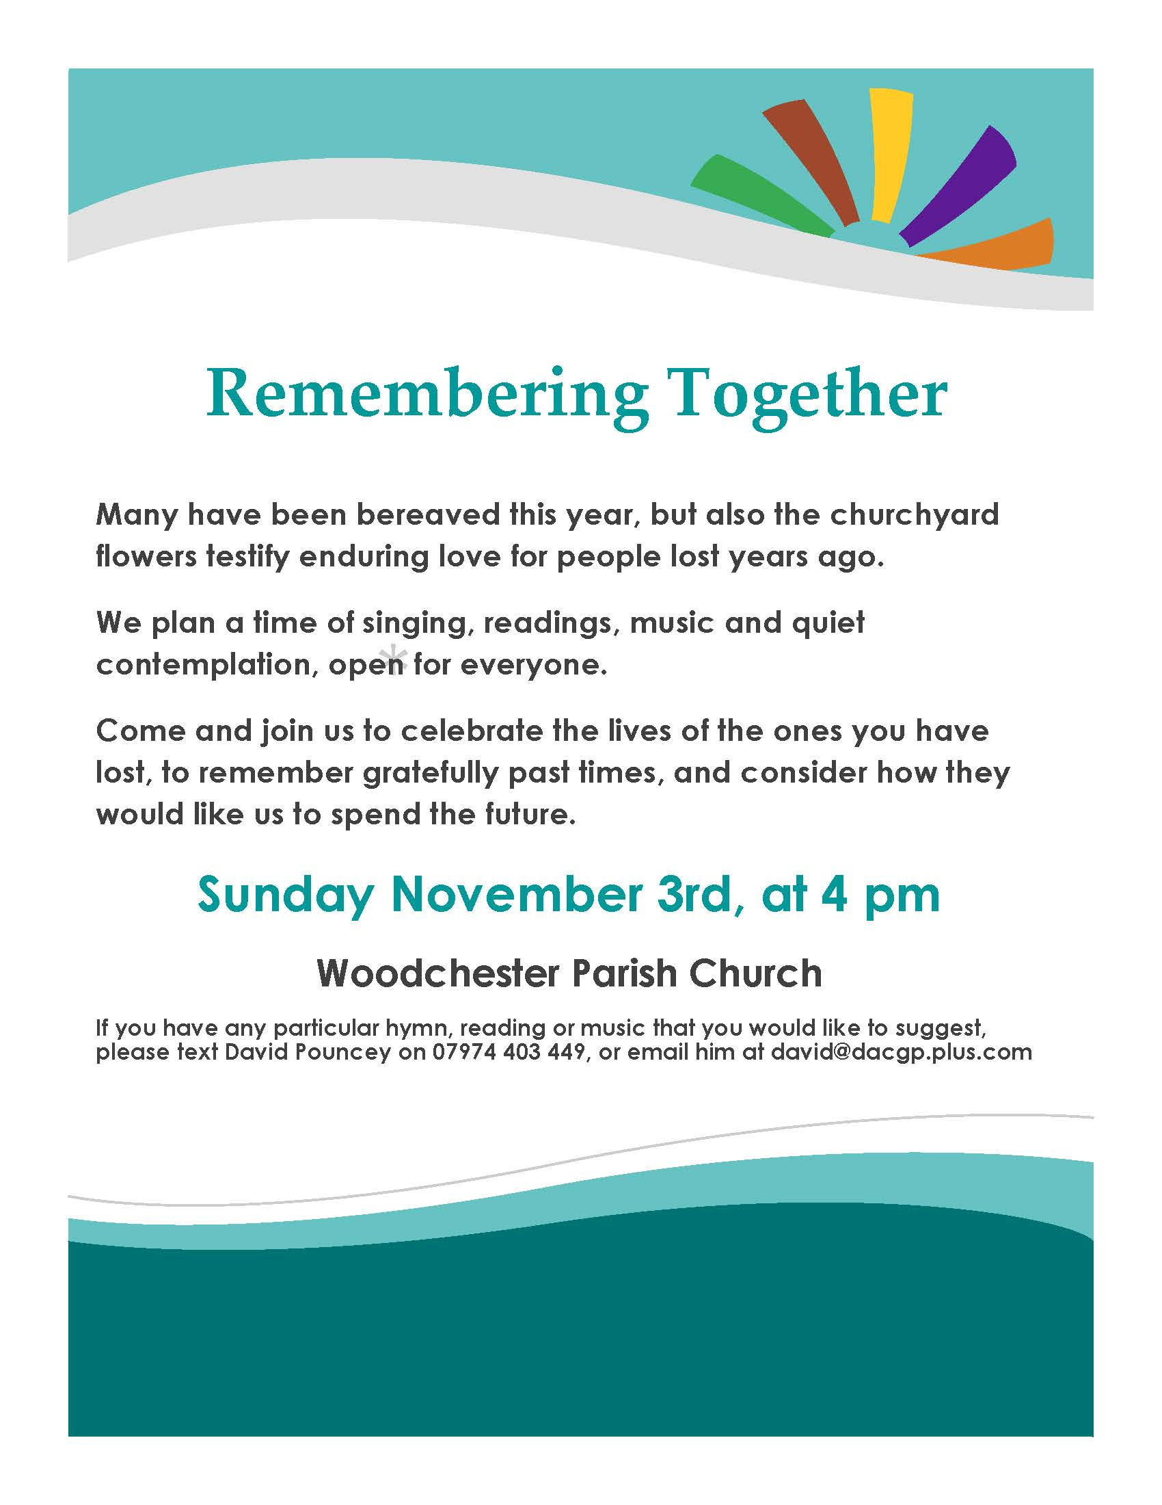

Church Openings
St Mary’s, Woodchester will be open daily, between 10am and 4pm.
St Mary Magdalene, Rodborough will be open daily, between 10am and 4pm.
Holy Trinity, Brimscombe will be open daily, between 8am-6pm.
Zoom Services
You can access these sessions via the following link:
https://us02web.zoom.us/j/8838649918?pwd=a1ZNU2FEN1VTUFNGS2g4b0VycSs1QT09
Or Zoom
Meeting ID: 883 864 9918 Password: blessed

Access by telephone:
• • Dial 0330 088 5830 local rate number (or 0208 880 6591 if it’s engaged)
• • When asked for a meeting-id enter 883 864 9918 on the keypad, followed by #
• • You will then be asked for participant-ID but you don’t have to answer this, just type another #
• • You may also be asked for a security code – enter 866912.

-------------------------------------------------------------------------------------------------

Contact details:

Rev. Peter Francis

- 01453 759680
- 07740 677645
- peterfrancis777@gmail.com

